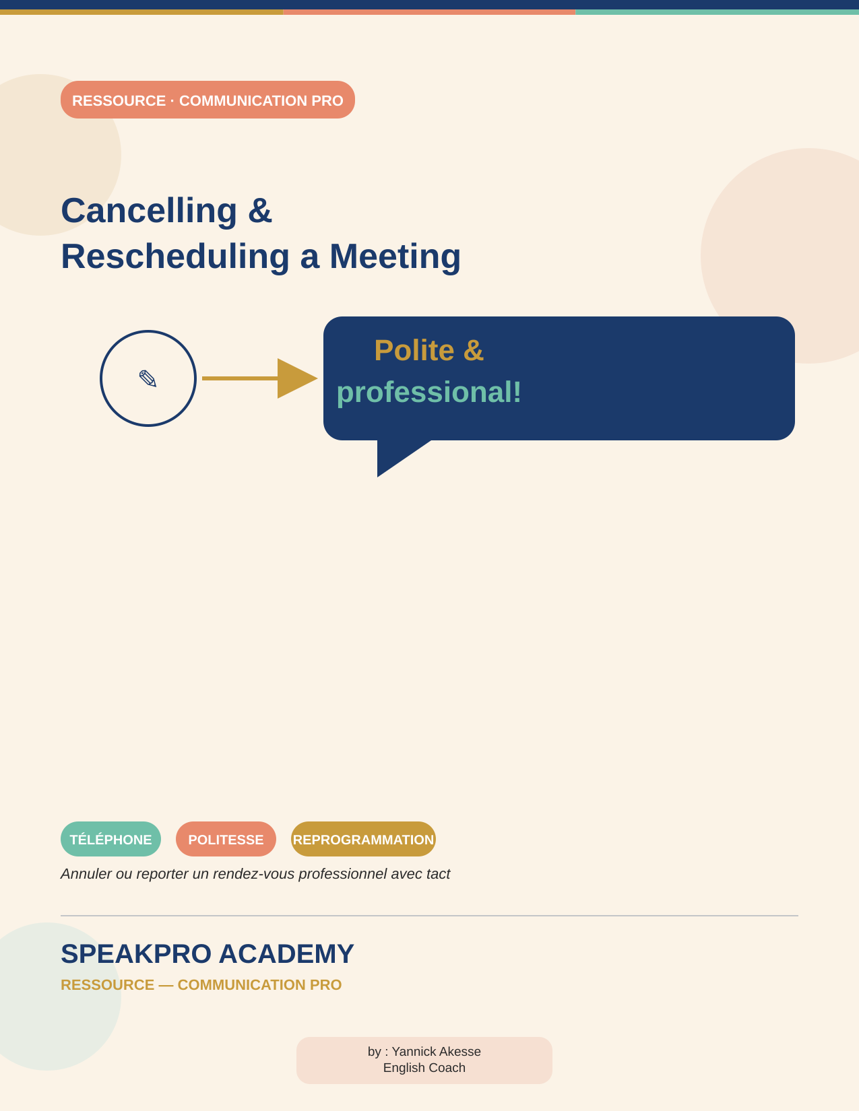

Contexte
Dans un environnement professionnel très chargé, il arrive souvent de devoir annuler un rendez-vous : conflit d'agenda, maladie, obligation professionnelle. Il est essentiel d'informer rapidement la personne concernée, avec courtoisie — cela augmente les chances de reprogrammer facilement.

Exemple d'appel d'annulation
📞 Appel téléphonique type
A: Hello? It's Jack. I'm calling to let you know that, unfortunately, I won't be able to make that appointment. I've come down with a terrible flu.
B: I'm sorry to hear that — I hope you feel better soon.
A: Thanks. I'd love to reschedule for next week, when I'm feeling better.
B: That'd be great! Does next Tuesday at nine work — maybe over breakfast?
A: It sure does! See you then.
💡 Rapidité et courtoisie sont les deux clés d'un appel d'annulation réussi.

Expressions clés pour annuler
Expression | Usage
I won't be able to make it. | Je ne pourrai pas venir.
I'm calling to let you know that… | Introduire une information poliment.
Unfortunately… | Introduire une mauvaise nouvelle.
I apologize for the inconvenience. | Très professionnel et poli.
I've come down with… | Je suis tombé malade de…

Expressions pour reprogrammer
Expression | Usage
If you're open to it… | Suggestion polie.
I'd love to reschedule. | Montre l'intérêt et le professionnalisme.
Whenever works for you is good for me. | Flexible et respectueux.
What day and time were you thinking? | Demander poliment la disponibilité.
Does next Tuesday at nine work? | Question standard de planification.

Vocabulaire professionnel utile
Mot | Sens
scheduling conflict | conflit d'agenda
fulfill an obligation | remplir une obligation
reschedule | reprogrammer
mandate | consigne officielle
courteous | poli
convey | communiquer
restructure | réorganiser

Mise en situation — Perseus Mining
🎭 Conversation complète
Daniels: Good morning, Ms. Brown. I'm calling to let you know that, unfortunately, I won't be able to make our meeting tomorrow at 10 a.m.
Brown: Oh, I'm sorry to hear that. Is everything alright?
Daniels: I've actually come down with a severe cold. I sincerely apologize for the inconvenience.
Brown: I understand completely. Health comes first. I hope you feel better soon.
(Dialogue complet fourni en séance.)

Erreurs fréquentes des francophones
❌ Erreur | ✅ Correction | Explication
I have 25 years. | I am 25 years old. | L'anglais utilise « to be », pas « to have », pour l'âge.
I assist to the meeting. | I attend the meeting. | « Assist » = aider ; « attend » = assister à.
I am agree. | I agree. | Agree est un verbe, pas un adjectif.
I have hunger. | I am hungry. | Les sensations utilisent « to be ».
He explained me the lesson. | He explained the lesson to me. | explain something TO someone.
I look forward to meet you. | I look forward to meeting you. | look forward to + verbe en -ING.
I am in Abidjan since 2020. | I have been in Abidjan since 2020. | « since » demande le present perfect.
Open the light. | Turn on the light. | On ne « ouvre » pas la lumière en anglais.

